Logistic Regression
Task 2
Kiara A Ganger
Western Governors University
D208: Predictive Modeling

Part I: Research Question

Describe the Purpose of the Data Analysis

Research Question:
What factors influence customer churn?

The goals of Data Analysis:
The goal of this analysis is to:
- Identify key factors influencing customer churn
- To create a logistic regression model that will help in predicting customer churn
- Give insight to help reduce customer churn

Part II: Method Justification

Describe Logistic Regression Methods

Assumptions of Logistic Regression:
Summary of four assumptions:
- The response variable is binary: The outcome of the response variable should only take on two outcomes.
- Observations are Independent: Observations should be independent of each other.
- No Multicollinearity: Predictor variables should not be highly correlated.
- Large Sample Size: A large sample size is required for reliable results. Meaning I would need a minimum of 10.
(Bobbitt, Introduction to Logistic Regression, 2020)

Benefits of Using R:
Three important benefits of using the R Programming Language are:
- Data Manipulation: Packages like ‘dplyr’ make it easy to perform data manipulation
- Visualization: Packages like ‘ggplot2’ help create comprehensive and beautifully colored visualizations to help tell the story.
- Statistical Modeling: Functions like ‘glm’ work great for logistic regression (Bobbitt, The 6 Assumptions of Logistic Regression (With Examples), 2020)

Why Logistic Regression:
Logistic regression is appropriate for this task because it involves a binary outcome (e.g., churn vs. no churn). It will help me in the understanding of the relationship between the predictors and the probability of churn. Logistic regression uses a method known as maximum likelihood estimation that finds an equation in this form log[p(X) / (1-p(X))] = β0 + β1X1 + β2X2 + … + βpXp.
Xj = the predictor variable and
βj = The coefficient estimate for the jth predictor variable
(Bobbitt, How to Perform Logistic Regression in R (Step-by-Step), 2020)

Part III: Data Preparation

Summarize the Data Preparation Process

Data Cleaning Goals and Steps:
Goal for Data Cleaning:
- Treat duplicates
- Treat Missing Values including NULLS
- Treat Outliers
- Correct data types
- Ensure consistency
The steps used to achieve the goals:
In this task, I used several codes and steps from Task 1 to ‘clean’ the data. I ran scripts to identify and handle duplicates, missing values, and outliers. I treated outliers using the z-score method, a statistical approach that maintains the integrity of the variable distribution. I also excluded populations of 0, as they constituted less than 1% of the data. I converted all categorical variables into factors. According to (Tüzen, 2024), "When performing regression analysis or any statistical modeling in R, factors ensure that categorical variables are correctly interpreted, allowing models to account for categorical variations in the data”. For clarity, I renamed the survey columns Item1, Item2, ..., Item8, and added leading zeros to zip codes that were missing due to excel dropping them during the import process in the Zip column where necessary.
Code:
1. #Part C1.
2. # Install the tidyverse package
3. install.packages("tidyverse")
4. install.packages("caret")
5. install.packages("car")
6.
7. #Load the ggplot2 and tidyverse library
8. library(tidyverse)
9. library(ggplot2)
10. library(caret)
11. library(magrittr)
12. library(car)
13.
14. #Import the churn data
15. churn <-
16. read.csv("C:/Users/kiara/OneDrive/WGU MSDA/churn_clean.csv")
17. View(churn)
18.
19. #Getting to know the DATA
20. summary(churn)
21.
22. # Detecting Duplicates
23. duplicates <- duplicated(churn)
24. duplicate_count <- sum(duplicates)
25. #Print the results
26. print(duplicate_count)
27.
28. # Missing count per column
29. colSums(is.na(churn))
30. #treating hidden missing values
31. pop_percentage_of_zeros <- sum(churn$Population == 0) / nrow(churn) * 100
32. print(pop_percentage_of_zeros)
33. #since under 1% drop
34. churn <- subset(churn, Population != 0)
35.
36. # Remove Outliers
37. convars <- c(
38. 'Tenure',
39. 'Children',
40. 'Age',
41. 'Income',
42. 'Email',
43. 'Population',
44. 'Outage_sec_perweek',
45. 'Contacts',
46. 'Yearly_equip_failure',
47. 'Bandwidth_GB_Year',
48. 'MonthlyCharge'
49. )
50. churn <- churn %>%
51. filter(if_any(all_of(convars), ~ abs(. - mean(.)) <= 3 * sd(.)))
52.
53. #the renaming of the survey columns Item1, Item2 etc.
54. churn %<>% rename(
55. Timely_Response = Item1,
56. Timely_Fixes = Item2,
57. Timely_Replacements = Item3,
58. Reliability = Item4,
59. Options = Item5,
60. Respectful_Response = Item6,
61. Courteous_Exchange = Item7,
62. Active_Listening = Item8
63. )
64. #Zip formatted as a five-digit string with leading zeros
65. churn$Zip <- sprintf("%05d", churn$Zip)
66.
67. # List of all categorical variables
68. categorical_vars <- c(
69. "Churn",
70. "Contract",
71. "InternetService",
72. "City",
73. "State",
74. "County",
75. "Zip",
76. "Area",
77. "TimeZone",
78. "Job",
79. "Marital",
80. "Gender",
81. "Techie",
82. "Port_modem",
83. "Tablet",
84. "Phone",
85. "Multiple",
86. "OnlineSecurity",
87. "OnlineBackup",
88. "DeviceProtection",
89. "TechSupport",
90. "StreamingTV",
91. "StreamingMovies",
92. "PaperlessBilling",
93. "PaymentMethod",
94. "Timely_Response",
95. "Timely_Fixes",
96. "Timely_Replacements",
97. "Reliability",
98. "Options",
99. "Respectful_Response",
100. "Courteous_Exchange",
101. "Active_Listening"
102. )
103. # Convert all categorical variables to factors
104. churn <- churn %>%
105. mutate(across(all_of(categorical_vars), as.factor))
106.
107. # Part C2.
108. summary(churn$Churn)
109. summary(churn[c(
110. "Population",
111. "Children",
112. "Age",
113. "Income",
114. "Outage_sec_perweek",
115. "Email",
116. "Contacts",
117. "Yearly_equip_failure",
118. "Tenure",
119. "MonthlyCharge",
120. "Bandwidth_GB_Year",
121. "Timely_Response",
122. "Timely_Fixes",
123. "Timely_Replacements",
124. "Reliability",
125. "Options",
126. "Respectful_Response",
127. "Courteous_Exchange",
128. "Active_Listening"
129. )])
130.
131. # Part C3.
132. # Univariate visualizations for selected variables
133. ggplot(churn, aes(x = Churn, fill = Churn)) +
134. geom_bar() +
135. ggtitle("Distribution of Churn") +
136. scale_fill_manual(values = c("Yes" = "skyblue", "No" = "yellow"))
137.
138. ggplot(churn, aes(x = Population)) +
139. geom_histogram(binwidth = 10000, fill = "skyblue", color = "black") +
140. ggtitle("Distribution of Population")
141.
142. ggplot(churn, aes(x = Children)) +
143. geom_histogram(binwidth = 1, fill = "yellow", color = "black") +
144. ggtitle("Distribution of Children")
145.
146. ggplot(churn, aes(x = Age)) +
147. geom_histogram(binwidth = 5, fill = "pink", color = "black") +
148. ggtitle("Distribution of Age")
149.
150. ggplot(churn, aes(x = Income)) +
151. geom_histogram(binwidth = 10000, fill = "green", color = "black") +
152. ggtitle("Distribution of Income")
153.
154. ggplot(churn, aes(x = Outage_sec_perweek)) +
155. geom_histogram(binwidth = .75, fill = "purple", color = "black") +
156. ggtitle("Distribution of Outage Seconds per Week")
157.
158. ggplot(churn, aes(x = Email)) +
159. geom_histogram(binwidth = 2, fill = "green4", color = "black") +
160. ggtitle("Distribution of Email")
161.
162. ggplot(churn, aes(x = Contacts)) +
163. geom_histogram(binwidth = 2, fill = "thistle", color = "black") +
164. ggtitle("Distribution of Contacts")
165.
166. ggplot(churn, aes(x = Yearly_equip_failure)) +
167. geom_histogram(binwidth = 1, fill = "salmon", color = "black") +
168. ggtitle("Distribution of Yearly Equipment Failure")
169.
170. ggplot(churn, aes(x = Tenure)) +
171. geom_histogram(binwidth = 5, fill = "#7FFFD4", color = "black") +
172. ggtitle("Distribution of Tenure")
173.
174. ggplot(churn, aes(x = MonthlyCharge)) +
175. geom_histogram(binwidth = 5, fill = "#7AC5CD", color = "black") +
176. ggtitle("Distribution of Monthly Charge")
177.
178. ggplot(churn, aes(x = Bandwidth_GB_Year)) +
179. geom_histogram(binwidth = 200, fill = "burlywood", color = "black") +
180. ggtitle("Distribution of Bandwidth GB Year")
181.
182. ggplot(churn, aes(x = Timely_Response)) +
183. geom_histogram(binwidth = 1, fill = "darkseagreen", color = "black") +
184. ggtitle("Distribution of Timely_Response")
185.
186. ggplot(churn, aes(x = Timely_Fixes)) +
187. geom_histogram(binwidth = 1, fill = "chocolate", color = "black") +
188. ggtitle("Distribution of Timely_Fixes")
189.
190. ggplot(churn, aes(x = Timely_Replacements)) +
191. geom_histogram(binwidth = 1, fill = "darkslategray", color = "black") +
192. ggtitle("Distribution of Timely_Replacements")
193.
194. ggplot(churn, aes(x = Reliability)) +
195. geom_histogram(binwidth = 1, fill = "deepskyblue", color = "black") +
196. ggtitle("Distribution of Reliability")
197.
198. ggplot(churn, aes(x = Options)) +
199. geom_histogram(binwidth = 1, fill = "honeydew3", color = "black") +
200. ggtitle("Distribution of Options")
201.
202. ggplot(churn, aes(x = Respectful_Response)) +
203. geom_histogram(binwidth = 1, fill = "lemonchiffon3", color = "black") +
204. ggtitle("Distribution of Respectful_Response")
205.
206. ggplot(churn, aes(x = Courteous_Exchange)) +
207. geom_histogram(binwidth = 1, fill = "lavenderblush", color = "black") +
208. ggtitle("Distribution of Courteous_Exchange")
209.
210. ggplot(churn, aes(x = Active_Listening)) +
211. geom_histogram(binwidth = 1, fill = "goldenrod1", color = "black") +
212. ggtitle("Distribution of Active_Listening")
213.
214.
215. # Bivariate visualizations including the dependent variable
216. ggplot(churn, aes(x = Population, fill = Churn)) +
217. geom_histogram(binwidth = 10000, color = "black") +
218. ggtitle("Churn Vs Population")
219.
220. # Continuous variables
221. ggplot(churn, aes(x = Children, fill = Churn)) +
222. geom_histogram(binwidth = 1, color = "black") +
223. ggtitle("Churn vs Children") +
224. scale_fill_manual(values = c("Yes" = "pink", "No" = "skyblue"))
225.
226. ggplot(churn, aes(x = Age, fill = Churn)) +
227. geom_histogram(binwidth = 5, color = "black") +
228. ggtitle("Age vs Churn") +
229. scale_fill_manual(values = c("Yes" = "white", "No" = "pink"))
230.
231. ggplot(churn, aes(x = Income, fill = Churn)) +
232. geom_histogram(binwidth = 15000, position = "dodge") +
233. ggtitle("Income vs Churn") +
234. scale_fill_manual(values = c("Yes" = "white", "No" = "green"))
235.
236. ggplot(churn, aes(x = Outage_sec_perweek, fill = Churn)) +
237. geom_histogram(binwidth = 100, position = "dodge") +
238. ggtitle("Outage Seconds per Week vs Churn")+
239. scale_fill_manual(values = c("Yes" = "black", "No" = "purple"))
240.
241. ggplot(churn, aes(x = Email, fill = Churn)) +
242. geom_histogram(binwidth = 2, color = "black") +
243. ggtitle("Churn vs Email") +
244. scale_fill_manual(values = c("Yes" = "snow", "No" = "green4"))
245.
246. ggplot(churn, aes(x = Contacts, fill = Churn)) +
247. geom_histogram(binwidth = 1, color = "black") +
248. ggtitle("Churn vs Contacts") +
249. scale_fill_manual(values = c("Yes" = "snow", "No" = "thistle"))
250.
251. ggplot(churn, aes(x = Yearly_equip_failure, fill = Churn)) +
252. geom_histogram(binwidth = 1, position = "dodge") +
253. ggtitle("Yearly Equipment Failure vs Churn")+
254. scale_fill_manual(values = c("Yes" = "azure", "No" = "salmon3"))
255.
256. ggplot(churn, aes(x = Tenure, fill = Churn)) +
257. geom_histogram(binwidth = 5, position = "dodge") +
258. ggtitle("Tenure vs Churn")+
259. scale_fill_manual(values = c("Yes" = "aquamarine4", "No" = "#7FFFD4"))
260.
261. ggplot(churn, aes(x = MonthlyCharge, fill = Churn)) +
262. geom_histogram(binwidth = 15, position = "dodge") +
263. ggtitle("Monthly Charge vs Churn")+
264. scale_fill_manual(values = c("Yes" = "#5F9EA0", "No" = "#7AC5CD"))
265.
266. ggplot(churn, aes(x = Bandwidth_GB_Year, fill = Churn)) +
267. geom_histogram(binwidth = 400, position = "dodge") +
268. ggtitle("Bandwidth GB Year vs Churn")+
269. scale_fill_manual(values = c("Yes" = "burlywood", "No" = "burlywood4"))
270.
271. ggplot(churn, aes(x = Timely_Response, fill = Churn)) +
272. geom_histogram(binwidth = 1, color = "black") +
273. ggtitle("Churn vs Timely_Response") +
274. scale_fill_manual(values = c("Yes" = "darkseagreen", "No" = "#698B69"))
275.
276. ggplot(churn, aes(x = Timely_Fixes, fill = Churn)) +
277. geom_histogram(binwidth = 1, color = "black") +
278. ggtitle("Churn vs Timely_Fixes") +
279. scale_fill_manual(values = c("Yes" = "chocolate4", "No" = "chocolate"))
280.
281. ggplot(churn, aes(x = Timely_Replacements, fill = Churn)) +
282. geom_histogram(binwidth = 1, color = "black") +
283. ggtitle("Churn vs Timely_Replacements") +
284. scale_fill_manual(values = c("Yes" = "darkslategray", "No" = "darkslategray1"))
285.
286. ggplot(churn, aes(x = Reliability, fill = Churn)) +
287. geom_histogram(binwidth = 1, color = "black") +
288. ggtitle("Churn vs Reliability") +
289. scale_fill_manual(values = c("Yes" = "deepskyblue", "No" = "deepskyblue4"))
290.
291. ggplot(churn, aes(x = Options, fill = Churn)) +
292. geom_histogram(binwidth = 1, color = "black") +
293. ggtitle("Churn vs Options") +
294. scale_fill_manual(values = c("Yes" = "honeydew", "No" = "honeydew3"))
295.
296. ggplot(churn, aes(x = Respectful_Response, fill = Churn)) +
297. geom_histogram(binwidth = 1, color = "black") +
298. ggtitle("Churn vs Respectful_Response") +
299. scale_fill_manual(values = c("Yes" = "lemonchiffon", "No" = "lemonchiffon3"))
300.
301. ggplot(churn, aes(x = Courteous_Exchange, fill = Churn)) +
302. geom_histogram(binwidth = 1, color = "black") +
303. ggtitle("Churn vs Courteous_Exchange") +
304. scale_fill_manual(values = c("Yes" = "lavenderblush4", "No" = "lavenderblush"))
305.
306. ggplot(churn, aes(x = Active_Listening, fill = Churn)) +
307. geom_histogram(binwidth = 1, color = "black") +
308. ggtitle("Churn vs Active_Listening") +
309. scale_fill_manual(values = c("Yes" = "goldenrod1", "No" = "goldenrod4"))
310.

Summary Statistics of Variables:
To see the summary of each variable being used I use the summary() function.
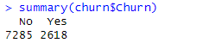
- Dependent Variable:
- Churn
- Independent Variables:
- Population: The population within 1 mile from the customer
- Children: The count of children the customer claims
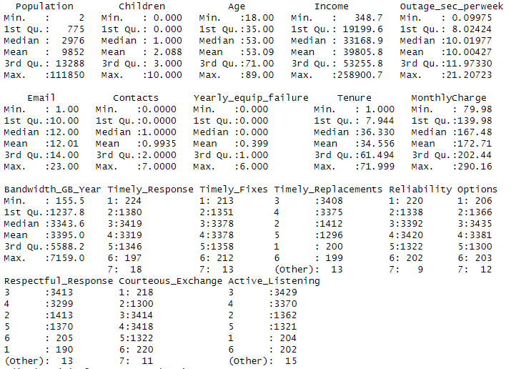
- Age: Age of customer
- Income: Customers income
- Gender: How the customer self-identifies
- Outage_sec_perweek: Avg outage sec perweek
- Yearly_equip_failure: Amount of equip failures per year
- Techie: Does the customer think of themselves as a techie?
- Contacts: How many times has the customer called tech support?
- Tenure: How long the customer has been with the company
- MonthlyCharge: customer’s monthly bill
- Bandwidth_GB_Year: Avg data usage in a year
- Survey Variables Ranking 1 to 8: Timely Response, Timely Fixes, Timely Replacements, Reliability, Options, Respectful Response, Courteous Exchange, Active Listening

Visualizations:
Univariate Analysis:
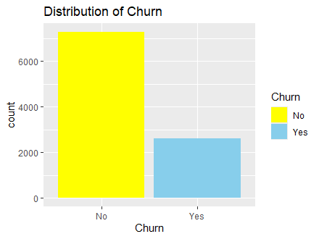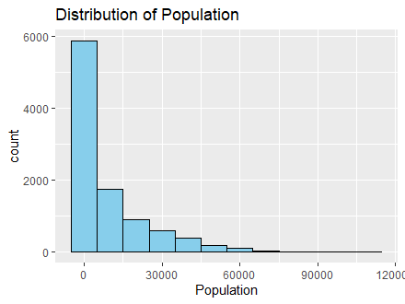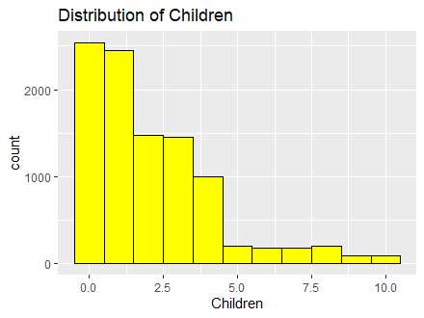
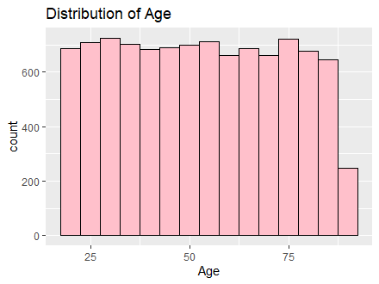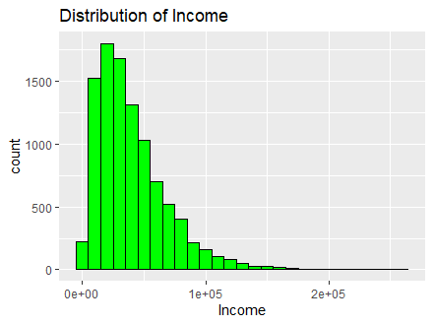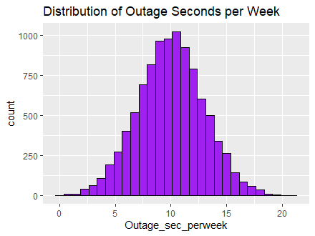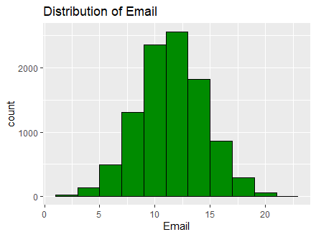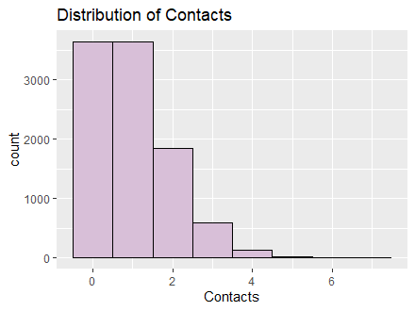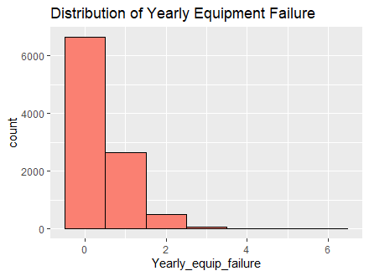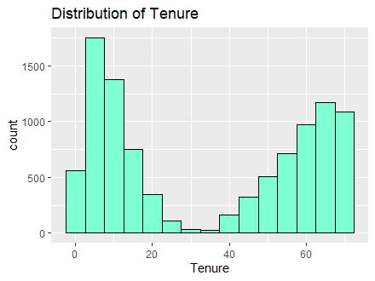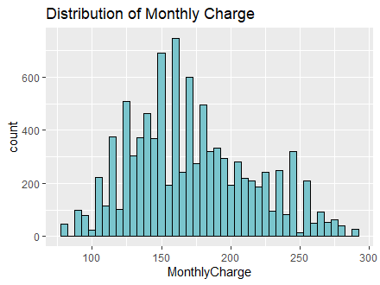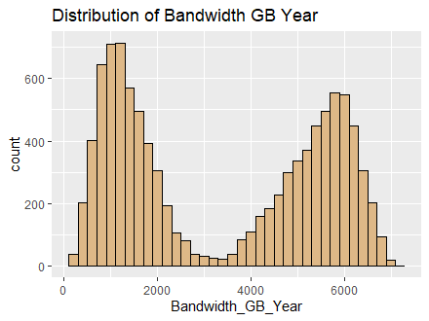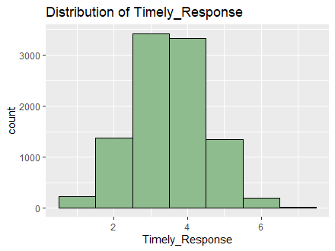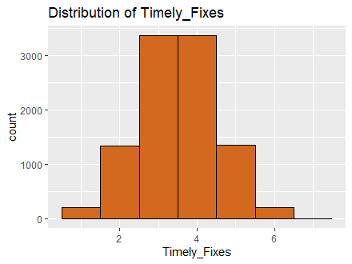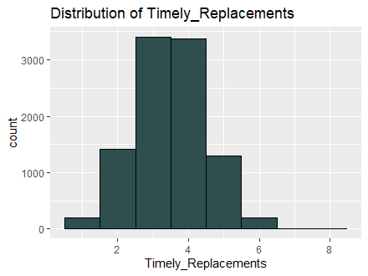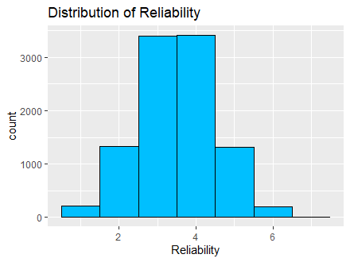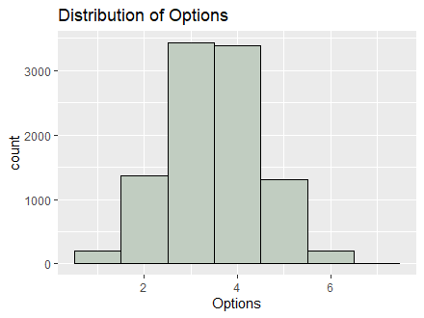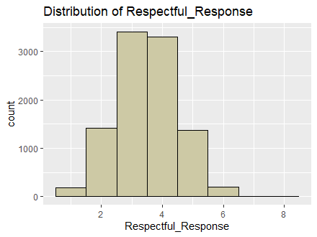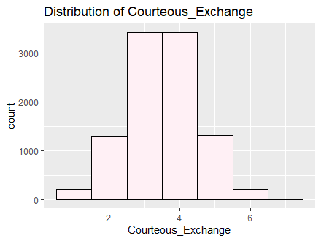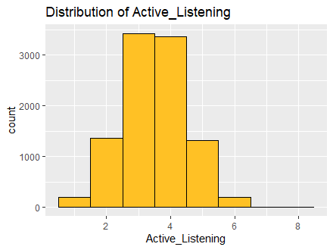
Bivariate Analysis:
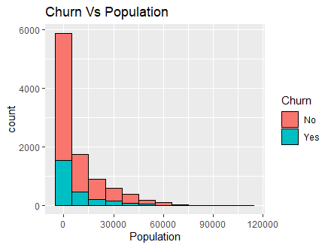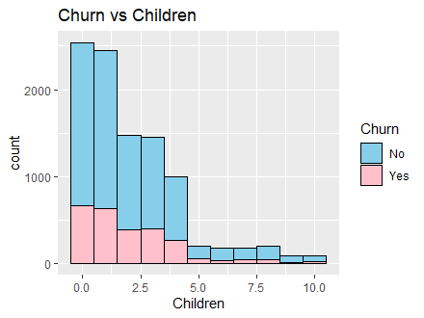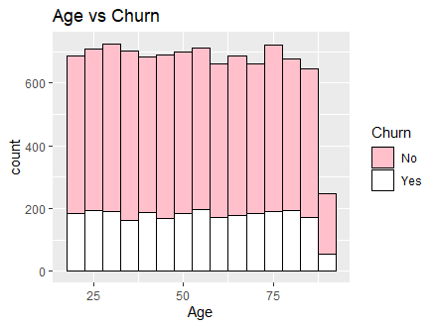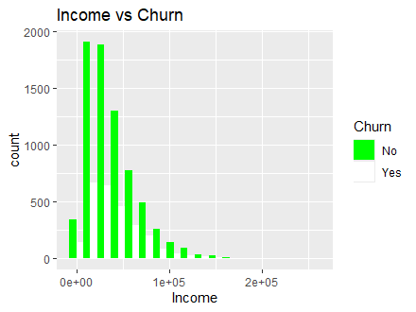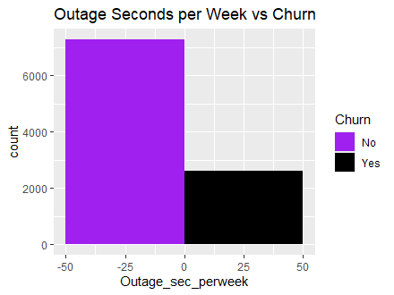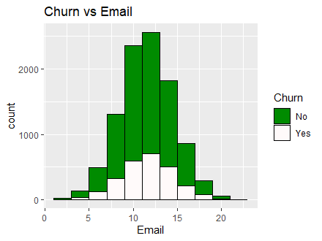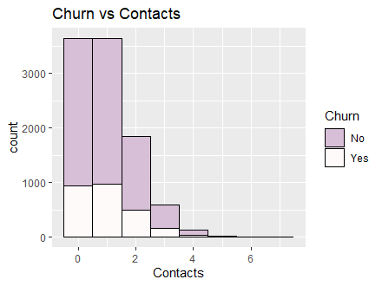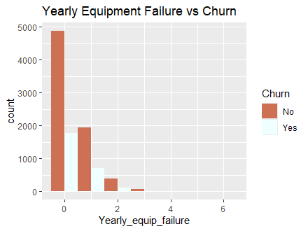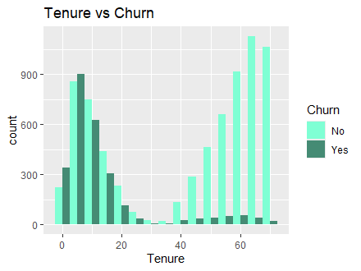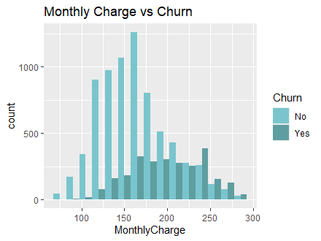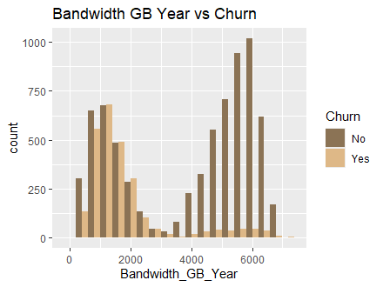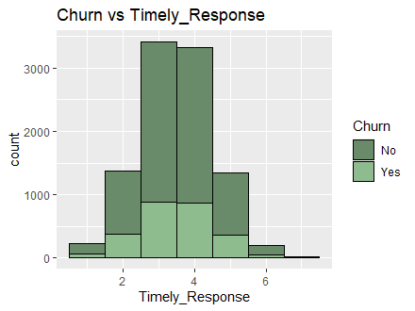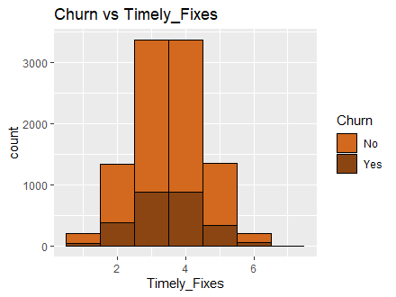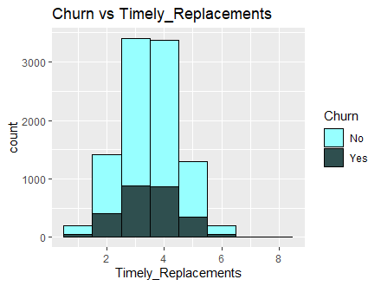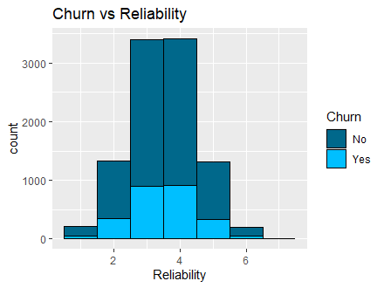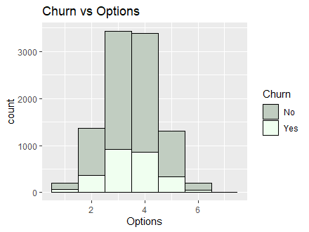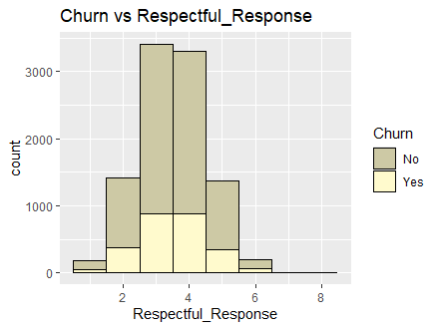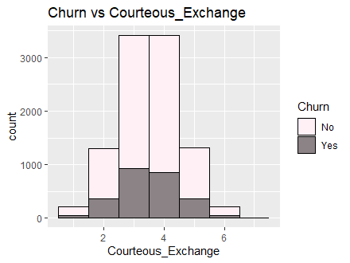
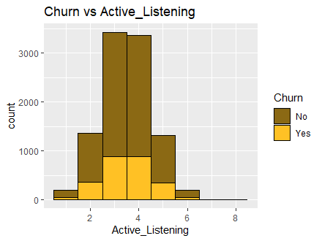

Data Transformation Goals and Steps:
Goals for Data Transformation:
- Prepare data for logistic regression.
- Check for multicollinearity
- Create subset for variables being used
Steps used to transform the Data:
The steps I took to transform the data were similar to the ones I took in task one. First, I used Ordinal Encoding to transform the columns that had a binary value of yes and no and ordinal value. In this case it was just the Churn column. Since I was not using any other categorical columns, I then checked for multicollinearity. Here I created a base model and ran the vif() function. In doing so, I discovered that Tenure and Bandwidth_GB_Year had values above 10. Since Bandwidth had the highest value, I dropped it and reran the code. By doing so, I noticed that the vif balanced out across the base model. Then I created a subset of the data to separate the variables I will be using for the logistic regression analysis.
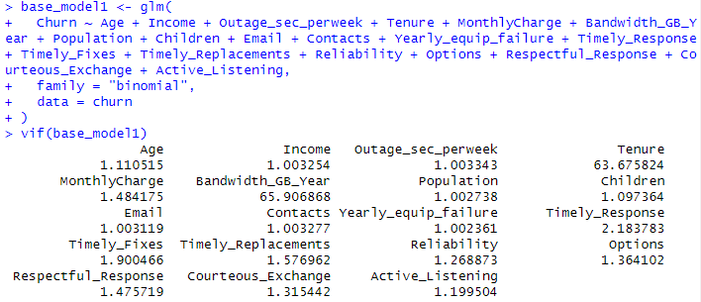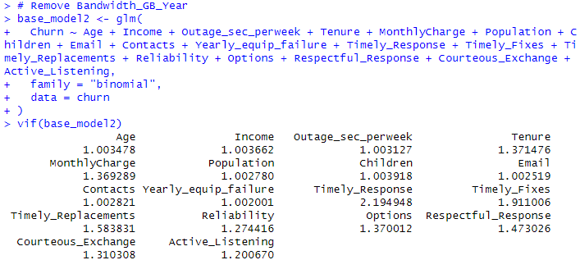

Provide the Prepared Data Set:
Dataset: task_2.csv

Part IV: Model Comparison and Analysis

Compare an initial and a reduced logistic regression model
To compare my initial and reduced logistic regression models I will be following these steps:
- Fit the Initial Logistic Regression Model - includes all the predictor variables minus the Bandwidth_GB_Year Column due to multicollinearity issues.
- Perform Variable Selection - backward elimination
- Fit the Reduced Logistic Regression Model - Fit the model with the selected subset of predictors
- Compare Models - Akaike Information Criterion

Initial Logistic Regression Model
To construct my initial logistic regression model, I will be using the following coding formula “model <- glm(default~student+balance+income, family="binomial", data=train)” (Bobbitt, How to Perform Logistic Regression in R (Step-by-Step), 2020)
Code:
1. # Part D1
2. # Initial Model
3. ini_mod <- glm(
4. Churn ~ Age + Income + Outage_sec_perweek + Tenure + MonthlyCharge + Population + Children + Email + Contacts + Yearly_equip_failure + Timely_Response + Timely_Fixes + Timely_Replacements + Reliability + Options + Respectful_Response + Courteous_Exchange + Active_Listening,
5. family = "binomial",
6. data = task_2
7. )
8. summary(ini_mod)
9. vif(ini_mod)
10. 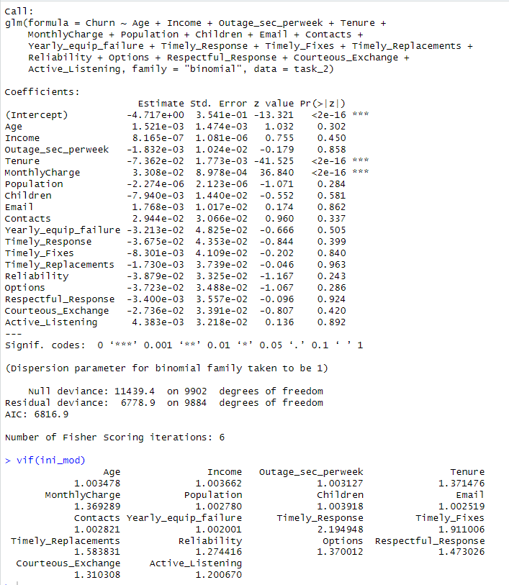

Feature Selection Procedure:
In this procedure I use the Wrapper Method: Backward Stepwise Elimination. Here I remove the predictor with the highest p-value. This will help improve the model, we keep repeating the process until we see no difference in the model. Each time I adjust the code to reduce the model I run the vif() code to verify if there was any change in multicollinearity. This method is justified, because it only keeps the predictors that have a statistical significance to the dependent variable.

Logistic Regression Model:
To construct my initial logistic regression model, I followed BSE starting with the highest p-valued predictor, Timely Replacements (Please follow the code and images below to see the process).
Code:
1. # Part D3
2. # Remove Timely Replacement
3. red_mod_01 <- glm(
4. Churn ~ Age + Income + Outage_sec_perweek + Tenure + MonthlyCharge + Population + Children + Email + Contacts + Yearly_equip_failure + Timely_Response + Timely_Fixes + Reliability + Options + Respectful_Response + Courteous_Exchange + Active_Listening,
5. family = "binomial",
6. data = task_2
7. )
8. summary(red_mod_01)
9. vif(red_mod_01)
10. 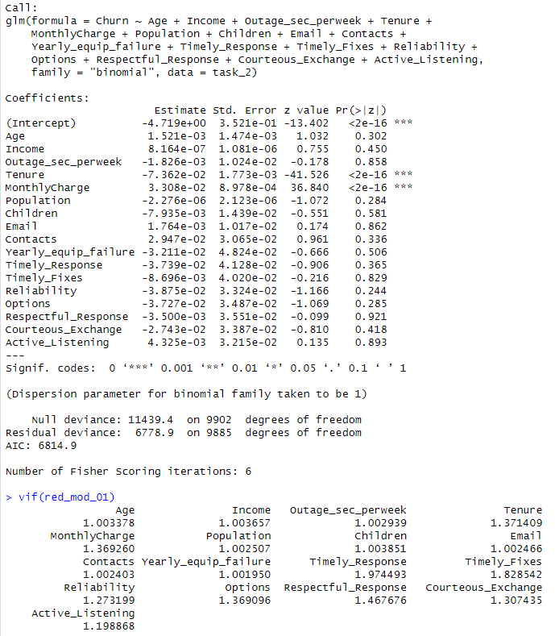
11. # Remove Respectful_Response
12. red_mod_02 <- glm(
13. Churn ~ Age + Income + Outage_sec_perweek + Tenure + MonthlyCharge + Population + Children + Email + Contacts + Yearly_equip_failure + Timely_Response + Timely_Fixes + Reliability + Options + Courteous_Exchange + Active_Listening,
14. family = "binomial",
15. data = task_2
16. )
17. summary(red_mod_02)
18. vif(red_mod_02)
19. 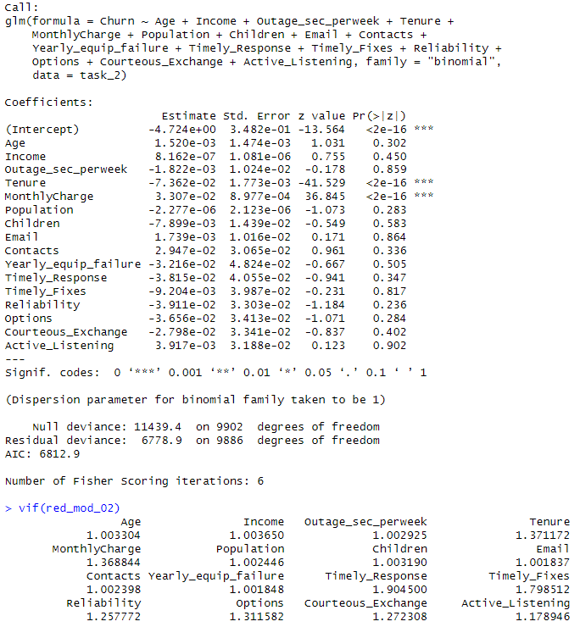
20. # Remove Active_Listening
21. red_mod_03 <- glm(
22. Churn ~ Age + Income + Outage_sec_perweek + Tenure + MonthlyCharge + Population + Children + Email + Contacts + Yearly_equip_failure + Timely_Response + Timely_Fixes + Reliability + Options + Courteous_Exchange,
23. family = "binomial",
24. data = task_2
25. )
26. summary(red_mod_03)
27. vif(red_mod_03)
28. 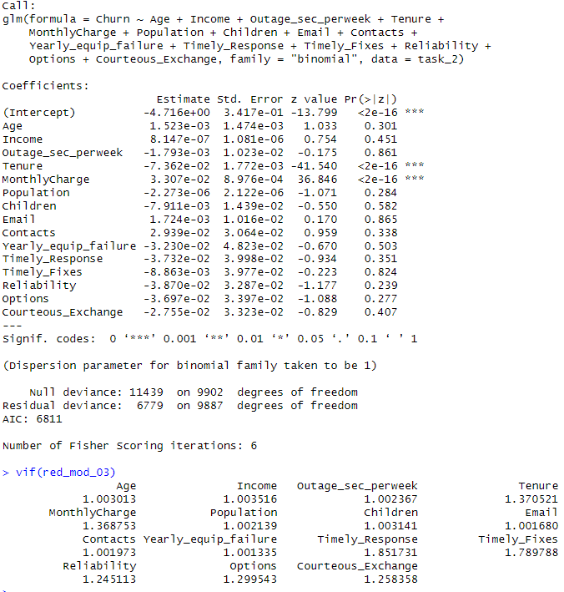
29. # Remove Email
30. red_mod_04 <- glm(
31. Churn ~ Age + Income + Outage_sec_perweek + Tenure + MonthlyCharge + Population + Children + Contacts + Yearly_equip_failure + Timely_Response + Timely_Fixes + Reliability + Options + Courteous_Exchange,
32. family = "binomial",
33. data = task_2
34. )
35. summary(red_mod_04)
36. vif(red_mod_04)
37. 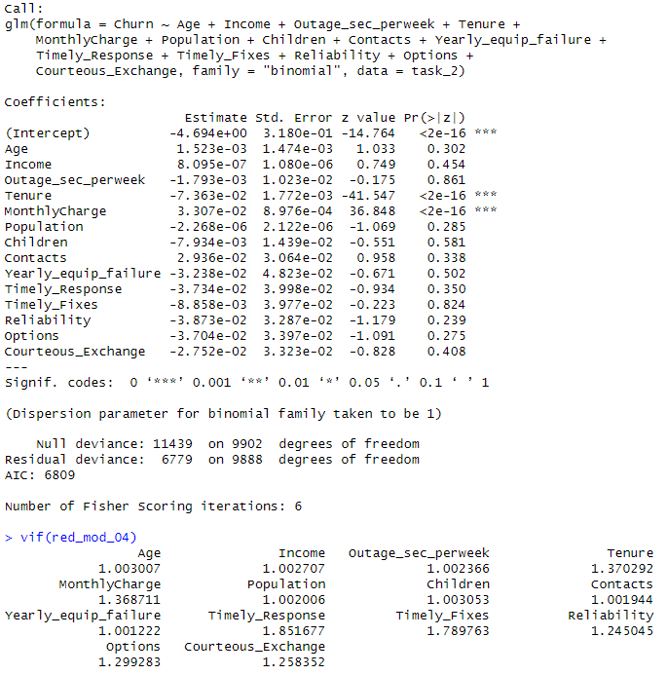
38. # Remove Outage_sec_perweek
39. red_mod_05 <- glm(
40. Churn ~ Age + Income + Tenure + MonthlyCharge + Population + Children + Contacts + Yearly_equip_failure + Timely_Response + Timely_Fixes + Reliability + Options + Courteous_Exchange,
41. family = "binomial",
42. data = task_2
43. )
44. summary(red_mod_05)
45. vif(red_mod_05)
46. 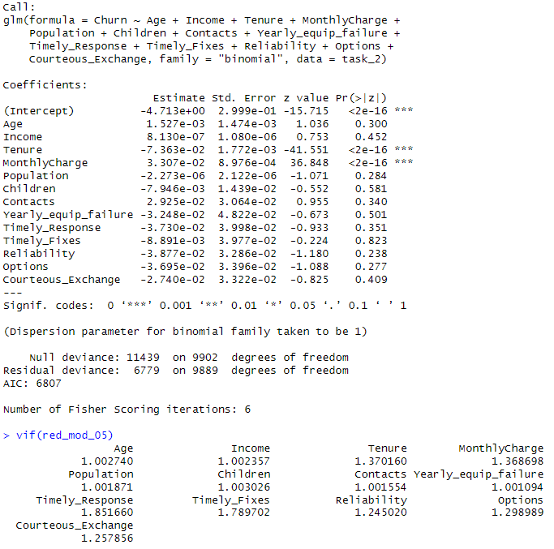
47. # Remove Timely_Fixes
48. red_mod_06 <- glm(
49. Churn ~ Age + Income + Tenure + MonthlyCharge + Population + Children + Contacts + Yearly_equip_failure + Timely_Response + Reliability + Options + Courteous_Exchange,
50. family = "binomial",
51. data = task_2
52. )
53. summary(red_mod_06)
54. vif(red_mod_06)
55. 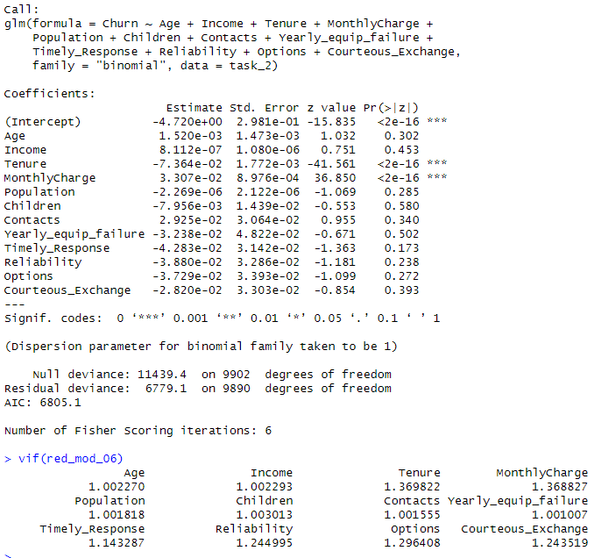
56. # Remove Children
57. red_mod_07 <- glm(
58. Churn ~ Age + Income + Tenure + MonthlyCharge + Population + Contacts + Yearly_equip_failure + Timely_Response + Reliability + Options + Courteous_Exchange,
59. family = "binomial",
60. data = task_2
61. )
62. summary(red_mod_07)
63. vif(red_mod_07)
64. 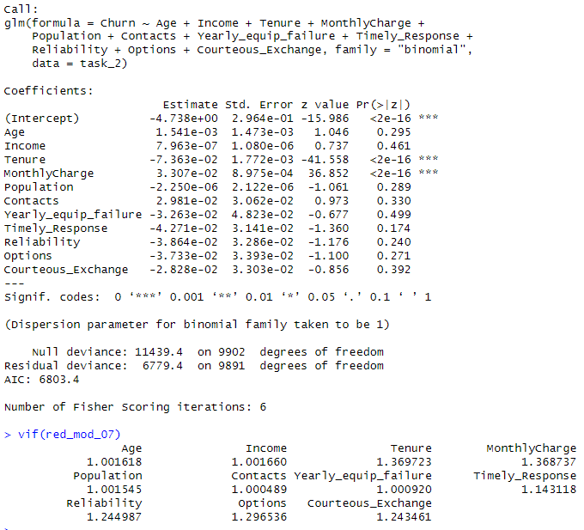
65. # Remove Yearly_equip_failure
66. red_mod_08 <- glm(
67. Churn ~ Age + Income + Tenure + MonthlyCharge + Population + Contacts + Timely_Response + Reliability + Options + Courteous_Exchange,
68. family = "binomial",
69. data = task_2
70. )
71. summary(red_mod_08)
72. vif(red_mod_08)
73. 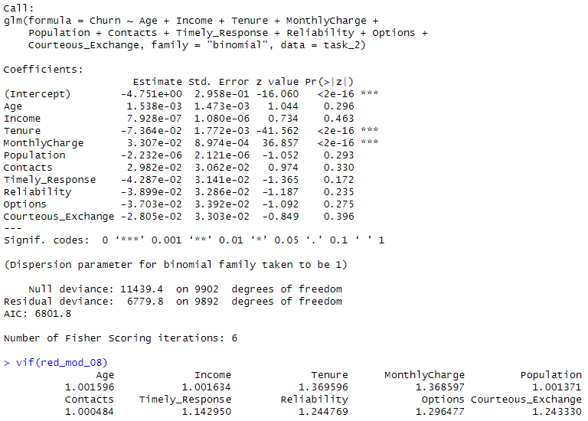
74. # Remove Income
75. red_mod_09 <- glm(
76. Churn ~ Age + Tenure + MonthlyCharge + Population + Contacts + Timely_Response + Reliability + Options + Courteous_Exchange,
77. family = "binomial",
78. data = task_2
79. )
80. summary(red_mod_09)
81. vif(red_mod_09)
82. 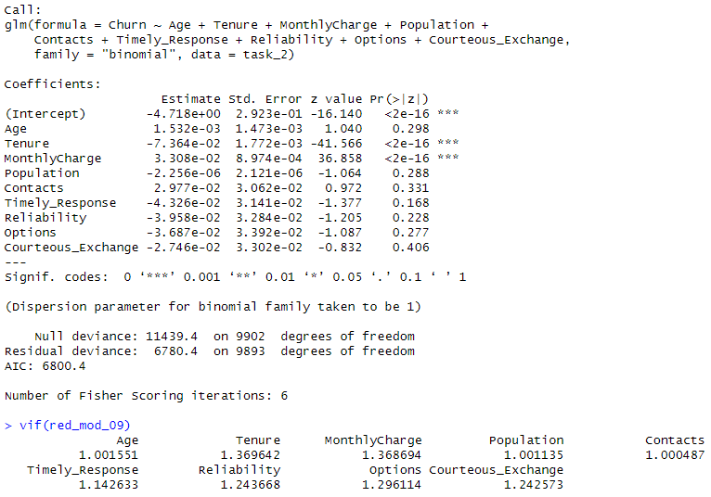

83. # Remove Courteous_Exchange
84. red_mod_10 <- glm(
85. Churn ~ Age + Tenure + MonthlyCharge + Population + Contacts + Timely_Response + Reliability + Options,
86. family = "binomial",
87. data = task_2
88. )
89. summary(red_mod_10)
90. vif(red_mod_10)
91. 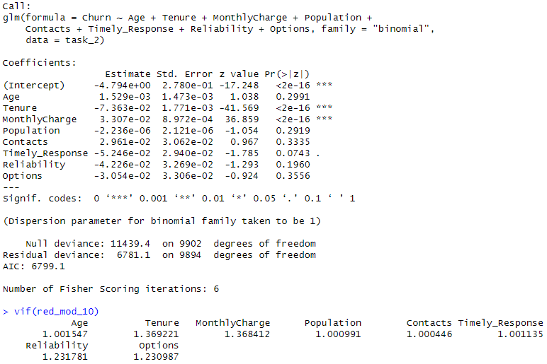
92. # Remove Options
93. red_mod_11 <- glm(
94. Churn ~ Age + Tenure + MonthlyCharge + Population + Contacts + Timely_Response + Reliability,
95. family = "binomial",
96. data = task_2
97. )
98. summary(red_mod_11)
99. vif(red_mod_11)
100. 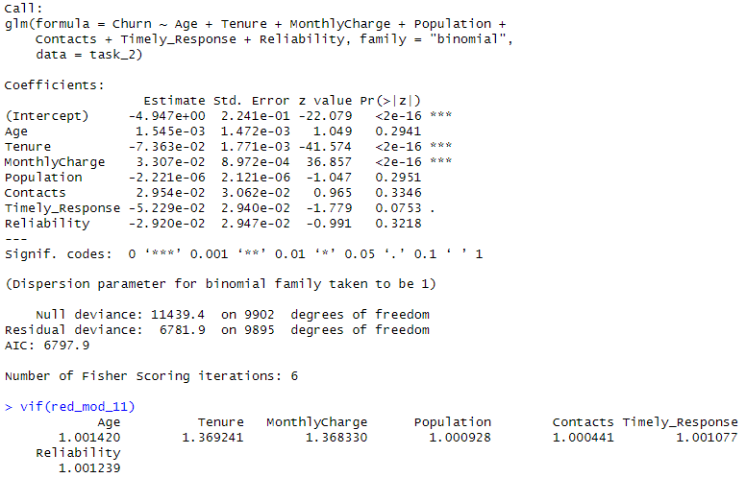
101. # Remove Contacts
102. red_mod_12 <- glm(
103. Churn ~ Age + Tenure + MonthlyCharge + Population + Timely_Response + Reliability,
104. family = "binomial",
105. data = task_2
106. )
107. summary(red_mod_12)
108. vif(red_mod_12)
109. 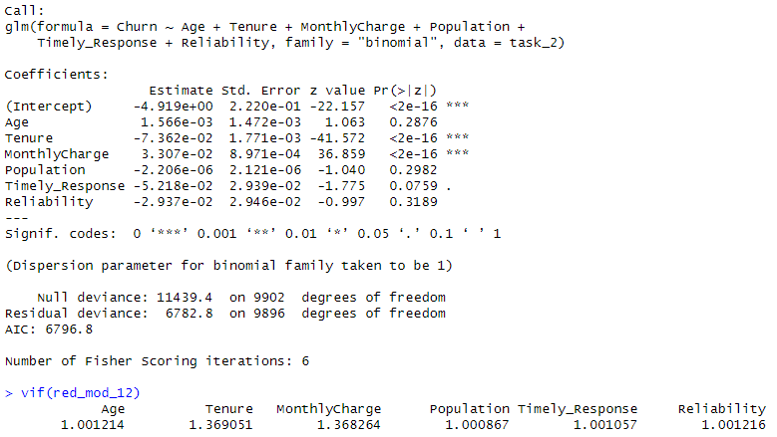
110. # Remove Reliability
111. red_mod_13 <- glm(
112. Churn ~ Age + Tenure + MonthlyCharge + Population + Timely_Response,
113. family = "binomial",
114. data = task_2
115. )
116. summary(red_mod_13)
117. vif(red_mod_13)
118. 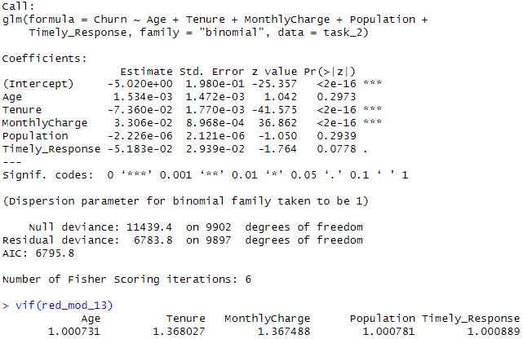
119. # Remove Age
120. red_mod_14 <- glm(
121. Churn ~ Tenure + MonthlyCharge + Population + Timely_Response,
122. family = "binomial",
123. data = task_2
124. )
125. summary(red_mod_14)
126. vif(red_mod_14)
127. 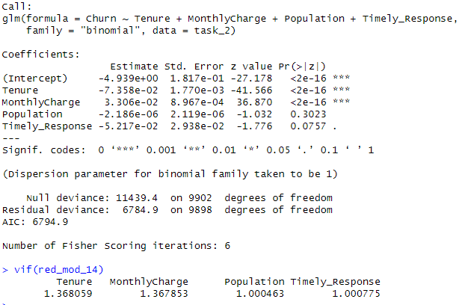
128. # Remove Population
129. red_mod_15 <- glm(
130. Churn ~ Tenure + MonthlyCharge + Timely_Response,
131. family = "binomial",
132. data = task_2
133. )
134. summary(red_mod_15)
135. vif(red_mod_15)
136. 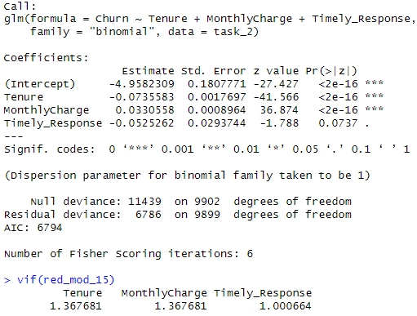
137. # Remove Timely Response
138. red_mod_16 <- glm(
139. Churn ~ Tenure + MonthlyCharge,
140. family = "binomial",
141. data = task_2
142. )
143. summary(red_mod_16)
144. vif(red_mod_16)
145. 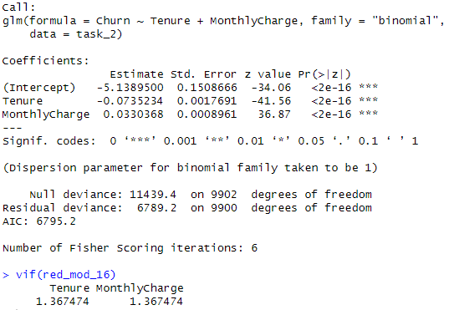

Analyze the data set using your reduced logistic regression model

Initial Model Reduced Model

Compare the models
Number of Predictors:
Initial Model: 18
Final Model: 2
Number of Multicollinearity:
Initial Model: 2
Final Model: 0
Model Evaluation Metric:
AIC: Akaike’s Information Criteria:
I used the AIC to evaluate and compare models. A lower AIC value indicates a better fit while penalizing the number of parameters to avoid overfitting.
Initial Model: 6816.9
Final Model: 6795.2
The reduced model has a lower AIC. Pointing to a better fit with less variables. This simplifies the model while retaining predictive power.

Output and Calculations
- Confusion Matrix
1. # Confusion Matrix
2. predictions <- ifelse(predict(red_mod_16, type = "response") > 0.5, 1, 0)
3. # Creating a confusion matrix
4. conf_matrix <- table(Predicted = predictions, Actual = task_2$Churn)
5. print(conf_matrix)
6. 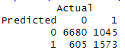
- Accuracy Calculation
1. # Calculating accuracy
2. accuracy <- sum(diag(conf_matrix)) / sum(conf_matrix)
3. print(accuracy)
4.

Copy of The Code
File: TASK2CODE.R

Part V: Data Summary and Implications

Summary of Findings and Assumptions

Discuss the Results of Your Data Analysis
- Regression Equation for the Reduced Model:
The regression equation for the reduced model is
$$\log\left(\frac{P\left(Churn\right)}{1-P\left(Churn\right)}\right)= -5.13895-0.07352 Tenure+0.03304 MonthlyCharge$$
P(Churn) is the probability that a customer will churn.
- Interpretation of the Coefficients:
- Intercept $\left(β0 = -5.13895\right):$ This is the log adds of customers churning when Tenure and Monthly Change are both at Zero.
- Tenure $\left(β1 = -0.07352\right)$: This number means that for each month a customer stays with the company the log odds of the customer churning decrease by 0.07352. In simple, the longer the customer stays the less likely it is that they will leave.
- MonthlyCharge $\left(β2 = 0.03304\right):$ Here we see that for every additional dollar increase in the monthly charge. The likelihood of the customer churning increasing by 0.03304.
- Statistical and Practical Significance of the Reduced Model:
- Statistical Significance:
Tenure and Monthly Charge are in the reduced model are highly statistically significant. They have p-values less the 0.001 which indicates strong evidence against the null hypothesis. Suggesting that the predictors are related to churn. The AIC is 6795.2 compared to the 6816.9 in the initial model, indicating better balance between model fit. Making this model Statistical Significance.
- Practical Significance:
This model is Practically Significant because, both predictors give us information into why or why not customers churning. For example, Tenure: the longer they stay the less likely they will leave. Monthly Charge: The more you charge the more likely they will leave.
- Limitation of The Analysis:
Similar to my analysis in task one, my analysis is limited to quality and completeness of the data. Any data that has been removed like the ones in the Population column may impact what the outcomes are. Even though the reduced model has been simplified, it may be oversimplified. Meaning that those to variable may not be the only two factors that led to churning. They may be other factors, but since logistic regression can identify associations and not establish causation, we can’t see it in this model. This model is also based on old data. It may not reflect current needs.

Recommended Course of Action
Based on the outcome from the model, I can recommend the following:
- Create a loyalty program:
Create a program to provide benefits to the customers that have soon loyalty. Offer reward and discounts for longer tenure
- Review the pricing
Consider offering discounts to customers that are at risk of churning. Looking into building services to help customers lower their monthly charge.
- Surveys
Conduct regular surveys to stay up to date with how customers feel about the products and services being delivered. Making changes to the customer service base on those surveys.
- Data
Create a dashboard that updates on a weekly or monthly basis, to keep stakeholders informed on how customers are doing and how the rates are looking. This will help them make better decisions.
By implementing these recommendations, the company can reduce customer churn, improve customer satisfaction, and increase profits.

Part VI: Demonstration

Panopto video
Link:
Ganger Task 2 (panopto.com)

Code Sources:
Bobbitt, Z. (2020, October 28). How to Perform Logistic Regression in R (Step-by-Step). Retrieved from Statology: https://www.statology.org/logistic-regression-in-r/

In Text Sources
Bobbitt, Z. (2020, October 27). Introduction to Logistic Regression. Retrieved from Statology: https://www.statology.org/logistic-regression/
Bobbitt, Z. (2020, October 13). The 6 Assumptions of Logistic Regression (With Examples). Retrieved from Statology: https://www.statology.org/assumptions-of-logistic-regression/
Bobbitt, Z. (2021, October 21). How to Fix in R: there are aliased coefficients in the model. Retrieved from Statology: https://www.statology.org/r-aliased-coefficients-in-the-model/
Tüzen, M. F. (2024, Janaury 10). Cracking the Code of Categorical Data: A Guide to Factors in R. Retrieved from R-bloggers: https://www.r-bloggers.com/2024/01/cracking-the-code-of-categorical-data-a-guide-to-factors-in-r/#:~:text=Statistical%20models%20often%20require%20categorical%20variables%20to%20be,to%20account%20for%20categorical%20variations%20in%20the%20data.

